**Introduction**

In this section

Firstly, to find out if there is a problem with document delivery on campus, we consulted with some of the administrators in the faculty and we learned that they do most of their administrative work is online. Although, some documents that need to be signed or stamped are sent physically to the deanship.

After that, we surveyed the campus. And we noticed a few things:

1. There are different terrains in the campus: streets, tiles, mud, grass, etc.
2. Often, there are students in the halls (roads?) between buildings
3. The buildings are wheel-chair accessible)

As shown in the figure, the distance between the faculty and the deanship of administration is approximately 240 meters

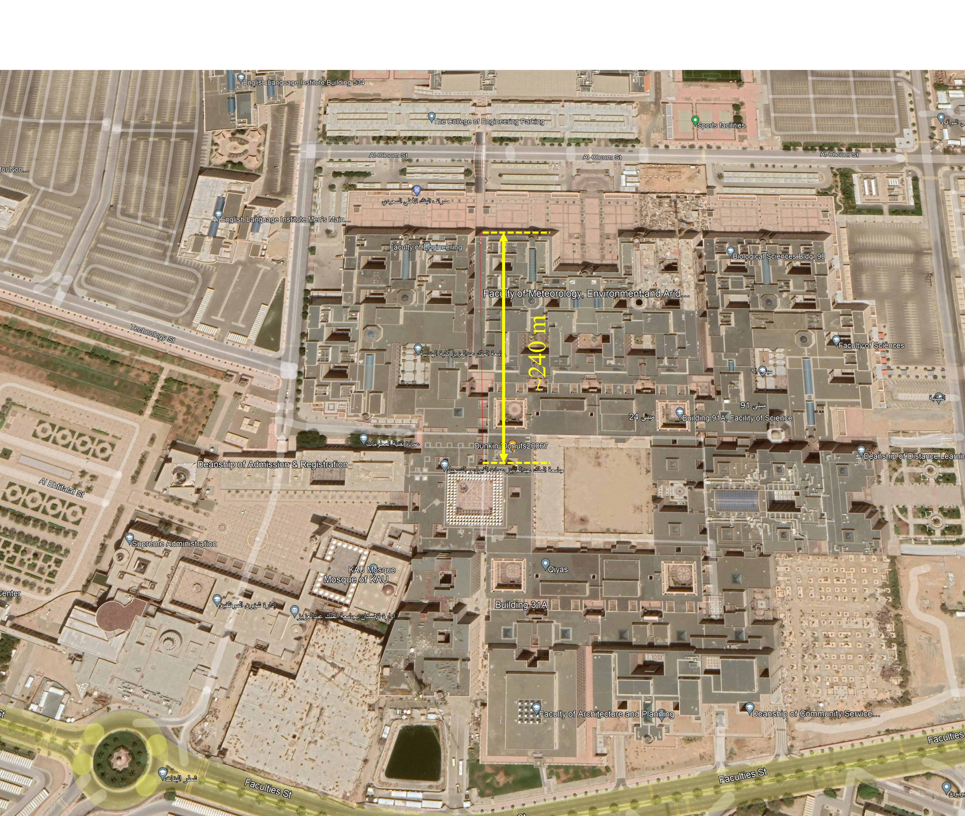

Figure 1 - Map of the region near the faculty of engineering